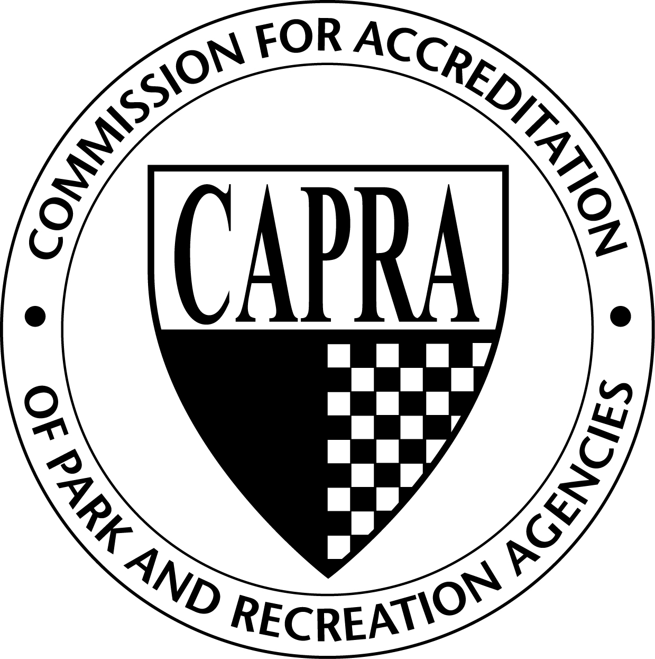

Commission for Accreditation of Park and Recreation Agencies

To: Accredited agencies, applicant agencies, and accreditation visitors

From: James Garges, CAPRA Chair

Subject: Spring 2012 CAPRA Update

Date: April 13, 2012

Thank you for your continued support of CAPRA and the accreditation process. As evidenced by the growing list of agencies seeking accreditation, our profession recognizes the value of accreditation. In times of budget cuts and downsizing, accreditation is still important for many agencies to pursue for the first time and for others to maintain. It demonstrates that an agency is well managed, proactive, reviews its management practices against the standards of practice developed by park and recreation professionals, and is providing cost-effective and comprehensive services.

The Commission met on March 29, 2012 and voted to implement the following changes to go into effect immediately. These changes have been reflected in the CAPRA Accreditation Handbook.

CAPRA Business Meetings and Hearings
The Commission will now meet four times per year, once in-person in the fall in conjunction with the NRPA Congress and Exposition and quarterly via teleconference. At its fall meetings, the Commission determines the accreditation status of agencies visited during the preceding spring/summer. Additionally, the Commission conducts regular business during these quarterly meetings.

Due to this change, all visits will now take place in the spring/summer and all hearings will occur in the fall. Agencies on a spring hearing cycle will be rescheduled for a fall hearing during the same year and will receive a letter in the next few weeks confirming this change.

Re-Accreditation Hearing Procedure
Neither the agency director nor the visitation team chair participates in a hearing before the Commission. The visitation team members and agency representatives are welcome to attend at their own expense; however there will be no opportunity for open discussion of the agency’s review. The Commission will request the agency director to participate in the hearing via teleconference in the following circumstances:
- The visitation report reported any unmet fundamentals; and/or
- The visitation report reported less than 85% of the non-fundamental standards were unmet; and/or
- The Visit Chair recommends to the Commission that the agency should participate in the hearing.

Initial accreditation hearings will still occur as previously outlined in the handbook with the requirement of the agency director and the visit chair to attend the hearing in person.

Complaint Policy and Procedures
The Commission has added a complaint policy and procedures section to the handbook. If a complaint is received, the Commission will follow the steps outlined in the policy.

Glossary of Terms
A glossary of terms has been added to the back of the CAPRA Accreditation Handbook to assist the agencies and visitors with commonly used accreditation terms.

Commission Mentors
A Commissioner will now be assigned to each preliminary applicant agency to provide guidance to the agency as they proceed through the accreditation process. If you are an applicant agency, expect to hear from your Commission Mentor in the near future.

Knowledge Center on NRPA Connect
Showcase your agency’s accreditation standards documents by logging in and posting them to the Knowledge Center within NRPA Connect. The Knowledge Center will quickly become a valuable resource for agencies looking for examples of the accreditation process, and we are asking for the assistance of the currently accredited agencies to populate this great resource with their materials. If you have documents you wish to share, follow these steps to post them:
- Log in to NRPA Connect
- Click on Knowledge Center
- Click on the “Accreditation” folder
- Click on the “CAPRA” folder
- Click on the appropriate standard folder
- Click on the “Add Document or Photo” link
- Locate your document, name it, and provide a brief description
- Click on “Upload File” at the bottom of the page
Upcoming Trainings
The list of upcoming CAPRA trainings can be found online at: http://www.nrpa.org/Professional-Development/Accreditation/CAPRA/CAPRA-Trainings/

We will be offering two more visit chair trainings on May 17th and August 16th. We will also be offering accreditation refresher trainings in June and September (the exact dates are TBD).

The Ohio Parks and Recreation Association is offering an in-person training on April 25th. We will offer a ½ day training workshop on October 15th in Anaheim, CA. The North Carolina Recreation and Park Association will be offering an in-person training at their state conference in November.

Next Meeting
The Commission will meet again in August via conference call to conduct business. Their fall meeting to conduct business and initial accreditation hearings will take place on Tuesday, October 16th at the Hilton Anaheim in Anaheim, CA.

Please contact CAPRA@nrpa.org with any questions regarding these changes. Thank you for your support.

